RETURNING YOUR DEVICE:
After removing the small reuseable patch slowly from the adhesive, place it back in the white charging case.
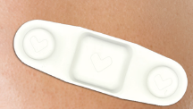
Place the case chargers, white charging block, phone, and any extra adhesives into the box (white or blue) and then place the box into the pre labelled envelope provided.
The envelope can then be dropped off at any FedEx store.

If you have used the larger white patch, follow the same steps as above, except you may throw the white patch away as it is disposable.
